Chapter 1
Introduction
Increase in traffic volume is one of the major problems faced by developing countries such as Zimbabwe. It is therefore evident that, monitoring traffic under such conditions is labor intensive and difficult. This makes it difficult to maintain control of traffic in urban areas. This can be a key contributor in the number of traffic violations for example during traffic congestion and can lead to accidents. Increased traffic volume results in increase in traffic congestion which has been a lead cause of lane violations and wrong way offenses by some drivers.
Red robot violations have also been among one of the traffic infractions happening country wide due to the lack of enough policing on intersections, as it requires massive deployment of road traffic police. This research therefore seeks to solve this problem by developing a surveillance system which maintains control in such areas by using computer vision which detects the offense committed by a certain vehicle ad capture the registration number of the vehicle and stores it. In general, computer vision is concerned with how a system can achieve high capabilities from input of images and videos. This project also entails the process of capturing the number plate of a vehicle and recording it.
Background
As most urban areas in Zimbabwe continue to experience significant growth, the volume of traffic has surged which has caused and increase in congestion and heightened risk of accidents. This therefore means safety for road users is a major concern. Such a scenario does not only complicates the process of traffic management but also escalates the number of traffic rule violations and road incidents which is a threat to human life. This research therefore proposes a solution to these problems by developing an automated traffic monitoring system to enhance traffic monitoring and enforcement of road rules through computer aided monitoring. The system aims to detect traffic in real-time, detect the traffic being committed and identify the vehicle that is violating the rules.
By employing the capabilities of computer vision, we can therefore obtain video feed and analyze it and achieve high level recognition of traffic violation. Central to the operation of this system is the use of convolutional neural networks. Which is a class of deep learning algorithms specifically adept at processing visual imagery. Through the tensor flow frame work, the system uses various libraries to facilitate in the detection and classification of traffic violations and thus ensuring reliability and efficiency. This research therefore is particularly important to the city traffic management authority as it seeks to improve safety in road usage and compliance through technology.
By automating the process of monitoring the responsible authority can allocate resources and respond promptly to violations, ultimately leading to safer road usage and improved and efficient traffic management. The proposed systems ability to address some of the violations highlights its targeted approach in providing solutions to the multifaceted challenges faced in contemporary scenarios.
Problem statement
The rapid growth in traffic volume in urban areas has led to significant challenges in managing road safety and compliance with traffic regulations by the road users. Traditional methods of traffic monitoring are resource intensive as they require deployment of personnel on the ground, which in some cases is inadequate. The methods of monitoring which require manual enforcement are not only inefficient but also prone to human errors which can exacerbate situations on the roads.
As the number the number of vehicles on urban roads continue to increase the limitations of the current monitoring systems becomes, more and more apparent. Traffic authorities often struggle to keep up with the growing demand of effective enforcement, resulting in a lack of oversight and increased risks for both drivers and pedestrians. This inefficiency can come with serious consequences including collisions, injuries and fatalities, highlighting the urgent need for a more effective solution.
Project aim
To develop an automated traffic violation detection system.
Objectives
- Design of miniature traffic environment
- Capturing traffic offenses
- License plate recognition
Significance of the study
The significance of the study extends beyond technological advancement. It provides a transformative approach to traffic management and enforcement for the traffic control agency. With the rise in traffic congestion and safety challenges in urban areas, the introduction of an automated traffic violation monitoring system utilizing computer vision technologies offers crucial benefits that enhances the safety of the public and aid in the law enforcement process. One of the primary advantages of this system is its ability to significantly improve public safety. By detecting violations in real time, the control agency can reduce the likelihood of accidents and promote road safety. The swift identification of offenders enables timely interventions and protecting both drivers and pedestrians in a landscape where road safety is a growing concern.
The introduction of such a method can act as a deterrent to potential violators, fostering a culture of compliance with traffic regulations. Additionally the automation of traffic monitoring promotes resource efficiency within the traffic control agency since traditional methods heavily relied on manpower and patrols which is both resource intensive and costly. By adopting an automated system, the traffic control agency can optimize the deployment of personnel allowing officers to focus on more strategic initiatives such as community engagement and crime prevention. This efficiency not only streamlines operations but also enhances the effectiveness of law enforcement and enabling the officers to respond proactively to traffic related issues.
Furthermore the data driven decision making the data driven decision making capabilities of the automated system are significant. This system generates comprehensive data on traffic violations which can be analyzed to identify patterns and trends. Such insights empower the control agency to make informed decisions involving policy changes, road design and targeted enforcement strategies. By harnessing the information, the traffic control agency can tailor its approach to meet the needs of urban areas thereby improving overall traffic management. The inclusion of a user friendly graphical user interface enhances the accessibility of the system by traffic control agency personnel. This intuitive interface allows personnel to monitor traffic violations in real time, access historical data and take actions with minimal training. By simplifying the enforcement process, the system allows officers to respond more effectively to traffic violations promoting accountability by drivers. The study focuses on multiple violations including signal, parking and direction violation. The holistic approach addresses various aspects of road safety allowing the traffic agency to enforce road regulations more efficiently and effectively.
Scope
The scope of this study focuses on the development of and implementation of an automated traffic violation system. In light of increasing traffic and safety challenges in urban areas this study focuses on leveraging computer vision technologies to address these pressing issues. At the core of the study is the objective of real time monitoring of traffic conditions. The proposed system is to obtain feed from cameras to continuously analyze and detect traffic violations as they occur. This capability is essential for the enhancement of road safety and ensuring compliance with traffic regulations.
The study focuses primarily on three types of violations which are signal, parking and direction violations. Each category of violation is addressed with tailored algorithms ensuring the system can accurately identify and respond to these infractions. By concentrating on these specific violations, the study seeks to provide a comprehensive solution that improves traffic management practices.
The technological framework utilizes advanced computer vision techniques, particularly employing the neural networks for vehicle classification and OpenCV library for image processing. The combination allows for efficient and accurate detection of vehicles and their behaviors which is critical for the systems overall effectiveness. Furthermore the study incorporates the design of a user friendly graphical user interface which is developed to facilitate the interaction of personnel with the system. This therefore enables the officers to monitor traffic in real-time, receive alerts for detected violations and efficiently manage violation records. By streamlining these processes, the system aims to enhance the operational capabilities of traffic enforcement.
Additionally the implementation involves a structured database that stores critical information about vehicles, detected violations and relevant traffic rules. This organized data management ensures seamless retrieval and handling of information, further supporting the enforcement process.
Assumptions of the research
The research is grounded on several key assumptions that are critical to the successful implementation of the automated traffic violation system. First it assume the sufficient and representative datasets will be available for the training of vehicle classification model. The quality and diversity of this data are essential to ensuring the models accuracy in effectively detecting vehicles.
Additionally the study assumes the cameras used for video capturing process in the project will be function properly and will be positioned to provide clear unobstructed views of the road. Proper positioning is essential for the accurate detection of the vehicles and violations. The reliability of computer vision algorithms and including image processing techniques is assumed to be high ensuring consistence with real time detection scenarios. Another assumption is that the traffic management personnel will receive adequate training to effectively use the interface and interpret the systems output. Proper training is essential for ensuring the officers can utilize the system to its full potential and respond effectively to detect violations.
Lastly the research assumes there exists supporting legal framework that allows for the use of automated systems in traffic enforcement. This includes regulations governing data privacy, video surveillance and the issuance of fines based on automated detections. A robust legal foundation is essential for the integration of this technology into existing traffic management practices.
Limitations
While the study aims to deliver significant advances in traffic monitoring and enforcement, several limitations must be acknowledged that may impact the effectiveness of the automated traffic detection system.
First and foremost the accuracy of the model is heavily dependent on quality and representativeness of the data used in training the model. If the datasets are limited or biased, the system’s ability to effectively classify vehicles and detect violations maybe compromised leading to suboptimal performance.
Additionally, the success of the system relies on the proper functioning and strategic placement of cameras. Poorly positioned or malfunctioning cameras can hinder the systems capability to accurately detect violations, potentially resulting in missed offenses. This reliance on hardware quality underscores the need for careful planning and installation.
Environmental conditions also pose a challenge to the systems effectiveness. Factors such as lighting variations, adverse weather conditions and road obstructions can affect the performance of the computer vision algorithms, leading to false positives or negatives in violation detection. Such external variables must be considered during the system implementation and design process.
Another critical implementation limitation is the necessity of adequate training of personnel to use the system interface and interpret the systems outputs. Insufficient training can limit the effectiveness of the system, undermining its potential benefits. Therefore, investing in comprehensive training programs is essential for maximizing the systems utility.
Furthermore the implementation of automated traffic monitoring systems may encounter regulatory and legal constraints. Issues related to data privacy, public acceptance of automated enforcement and legal framework governing traffic violations can pose significant challenges to the deployment and integration of the system within traffic management practices.

CHAPTER 2: LITERATURE REVIEW

Introduction
The rapid urbanization of Zimbabwe, particularly in the Harare metropolitan province, has placed immense strain on the built environment and transportation infrastructure. Traditional methods of traffic oversight in African nations frequently lack the resources and sophisticated technology required to manage increasing vehicle volumes effectively. In Zimbabwe, the current reliance on manual highway patrolling is increasingly viewed as inadequate and woeful due to its susceptibility to corruption and the lack of empirical evidence for independent auditing. Consequently, there is a significant move toward adopting automated traffic monitoring systems (ATMS) that integrate the Internet of Things (IoT), artificial intelligence (AI), and advanced computing architectures. Recent advancements in deep learning have transitioned traffic monitoring from simple anomaly detection to sophisticated, real-time automated systems. The integration of object detection models like YOLO and tracking algorithms such as DeepSORT has become the standard for maintaining consistent vehicle identification across video frames. These technologies are increasingly vital in smart society frameworks to enforce compliance and reduce the human error inherent in traditional policing. By automating the detection of specific infractions—such as traffic light, lane, and parking violations—urban centers can achieve a "virtual traffic police" presence that operates continuously.

Background of Traffic Violations in Zimbabwe
While global research emphasizes the move toward AI-driven enforcement, the Zimbabwean context remains heavily reliant on manual observation, which is prone to inefficiencies and oversight. The growth in urban road traffic has made it difficult for authorities to track multiple simultaneous offenses. There is a clear consensus in the literature that the lack of apprehension and enforcement leads to a culture where motorists frequently ignore traffic rules (Uy et al., 2016). Transitioning to an automated system is seen as a primary solution to enhance the efficiency and reliability of tracking these offenders in high-density urban environments (Kusumaningtyas et al., 2025).
Automated monitoring systems significantly improve the enforcement of traffic regulations by providing accurate and real-time detection. One of the most critical benefits is the reduction of human intervention, which minimizes errors in ticket generation and ensures a more transparent enforcement process (Akshit et al., 2025). High accuracy rates—exceeding 98% in some deep learning models—demonstrate the potential for these systems to outperform human observers (Abd Allah, 2023). Furthermore, the ability to generate "e-challans" delivered via SMS or email promotes immediate accountability and encourages more disciplined driving behavior (Singh, 2024).

Overview of Traffic Monitoring Systems
Modern traffic violation detection systems are defined by their use of image processing software routines to identify vehicles and assess compliance with specific road rules (Tan, 2013). Their purpose is to enhance road safety through the use of surveillance video feeds, particularly at intersections where signal violations are common (Gehani et al., 2024). These systems aim to create an intelligent traffic management environment that integrates violation detection, license plate localization, and character recognition into a single automated workflow (Uy et al., 2016). OpenCV (Open Source Computer Vision) is a famous open-source computer vision and machine learning library widely used in various fields, including robotics. One of the typical applications of OpenCV in autonomous robotics is lane detection, where the robot uses a camera to navigate along a lane.
To detect black lanes in autonomous robots, OpenCV provides several functions and algorithms that can be used. The following is a brief overview of the steps involved in using OpenCV for lane detection in autonomous robots. The first step is to capture the image of the lane using a camera mounted on the robot. This image is then used as input for the lane detection algorithm. The image must be preprocessed to enhance its quality before detecting the lanes. This can include resizing the image, adjusting the brightness and contrast, and applying filters such as Gaussian blur to remove noise. Next, the Canny edge detection algorithm is applied to the preprocessed image to extract the edges in the picture. This helps to identify the boundaries of the lanes. Since the robot only needs to navigate along the lane, a Region of Interest (ROI) is selected to focus on the area where the roads are present. This helps reduce the processing time and improve the detection accuracy. The Hough transform algorithm is then applied to the edge-detected image within the ROI to detect lines. This helps to identify the straight lines that represent the lanes.
Thresholding
Thresholding is a fundamental image processing technique in computer vision and image analysis applications. It is a method of segmenting an image into multiple parts or regions based on their intensity levels or pixel values. Thresholding is widely used in OpenCV (Open Source Computer Vision) library, a famous open-source computer vision and machine learning library for real-time image and video processing.
Thresholding converts grayscale or color images into binary images, where each pixel is black or white. The thresholding process involves comparing each pixel's intensity value with a threshold value and assigning a value of 255 (black) or 0 (white) based on whether the pixel value is below or above the threshold value.
OpenCV provides various thresholding techniques to threshold an image based on different criteria, such as the global threshold, adaptive threshold, and Otsu's threshold. Global Thresholding- This technique uses a single threshold value for the entire image. This threshold value is manually or calculated using automated algorithms such as Otsu's method. The pixels below the threshold are set to 0 (black), and those above the threshold are set to 255 (white). Adaptive Thresholding- In this technique, each pixel's threshold value is determined locally based on its surrounding pixel values. This technique is used when the lighting conditions in the image are not uniform. Adaptive thresholding uses a small region around each pixel to calculate the threshold value. Otsu's Thresholding- This technique automatically calculates the threshold value based on the image's histogram. The histogram represents the distribution of pixel values in the picture. The threshold value is estimated to maximize the variance between the two classes of pixels, i.e., the foreground and background.
Image warping or wrapping is a familiar image processing technique used in computer vision and image analysis applications to transform an image from one coordinate system to another. In OpenCV (Open Source Computer Vision) library, image wrapping is achieved using the cv2.warpPerspective () and cv2.warpAffine () functions.
The cv2.warpPerspective () function performs a perspective transformation on an image. This function takes an input image and a perspective transformation matrix as input and returns the transformed image. The perspective transformation matrix is a 3x3 matrix that defines the input and output image transformation. Perspective transformation is used to correct the image's perspective and remove distortions caused by the camera's viewing angle. The cv2.warpAffine () function performs the affine transformation on an image. This function takes an input image and an affine transformation matrix as input and returns the transformed image. The affine transformation matrix is a 2x3 matrix that defines the input and output image transformation. Affine transformation is used to rotate, scale, translate, and shear an image.

Types of Monitoring
Advanced monitoring now utilizes modular architectures that allow for independent operation of various machine learning components (Deshpande et al., 2026). Key methodologies include:
- Object Detection: Utilizing YOLOv5, YOLOv8, or YOLOv9 to identify vehicles, riders, and pedestrians in real-time (Bachate et al., 2025; Kusumaningtyas et al., 2025).
- Tracking: Implementing DeepSORT or SORT algorithms to follow a vehicle's path and determine its behavior concerning traffic rules (Akshit et al., 2025; Gehani et al., 2024).
- License Plate Recognition: Leveraging tools like OpenALPR or EasyOCR to extract alphanumeric registration details even under varied conditions (Arun, 2025; Bhavana, 2025).
- Environmental Compensation: Using techniques like RGB-Thermal Image Fusion to maintain detection accuracy in low-light or adverse weather (Gambhire et al., 2025).

Existing Systems
Literature highlights that governments in developing regions are increasingly exploring AI-based "Smart Traffic Guard" systems for real-time penalty enforcement (Thamilarasi et al., 2025). These initiatives often focus on replacing traditional traffic police with automated techniques to manage traffic jams and identify defaulters more effectively (Malik et al., 2023). There is a growing emphasis on creating structured databases to compile violation data, which assists authorities in identifying repeat offenders and tracking uncertified or stolen vehicles (Malik et al., 2023). The private sector has driven the adoption of scalable data management architectures, such as the MERN stack (MongoDB, Express, React, Node.js), to support real-time processing and web-enabled monitoring (Deshpande et al., 2026). Companies have also focused on integrating payment gateways directly into violation management systems to facilitate immediate online fine payments (Thamilarasi et al., 2025). The shift toward IoT-enabled and cloud-based solutions allows for more flexible and efficient communication between detection units and centralized law enforcement servers (Gambhire et al., 2025).

Challenges in Traffic Violation Monitoring
A significant research gap remains regarding the performance of AI models under extreme weather or varying lighting conditions (Arun, 2025; Rose et al., 2025). Systems may struggle with false positives in violation detection, which can lead to unjust penalties and a loss of public trust (Malik et al., 2023). Furthermore, the scalability of these models in areas with extremely high traffic density or diverse urban settings is often unexplored in current studies (Akshit et al., 2025; Kaur et al., 2025).The integration of automated systems with existing legal frameworks remains a major hurdle, particularly concerning the privacy of personal data captured in public spaces (Rose et al., 2025). Ethical concerns regarding automated surveillance and the potential for "digital authoritarianism" are frequently cited as barriers to public acceptance (Arun, 2025). To combat this, some systems have introduced face-blurring modules to preserve individual privacy while still identifying the vehicle involved in the infraction (Rose et al., 2025).

Comparative Analysis with Other Countries
The crucial problem of road safety in India has prompted the creation of integrated systems that incorporate "penalty points" to promote compliance and automate the issuance of penalties (Tulasidasu et al., 2025). Researchers are employing YOLO-based deep learning to address the unique issues of controlling high-density, chaotic traffic in cities like Dhaka (Kusumaningtyas et al., 2025). These case studies show that the fundamental requirement for automated surveillance and transparent fine issuing is ubiquitous across emerging urban contexts, even though the specific infractions may differ. The significance of a scalable and modular architecture that makes it simple to incorporate additional detection modules when traffic patterns change is a key takeaway (Rose et al., 2025; Deshpande et al., 2026). According to studies, detection accuracy is greatly increased when extensive datasets, such the COCO dataset, are used for initial model training (Gehani et al., 2024). Furthermore, modern neural network techniques may achieve over 90% accuracy in both detection and recognition, according to the shift to deep learning (Uy et al., 2016; Abd Allah, 2023).

Future Directions for Traffic Violations Monitoring in Zimbabwe
By combining automated ticketing systems with current law enforcement infrastructure, future systems should concentrate on closing the gap between detection and real-time notification (Thamilarasi et al., 2025). The sustainability and long-term upkeep of these technologies in regional settings must also be studied (Abd Allah, 2023). More long-term research is clearly needed to determine how well these systems actually reduce infractions over a number of years (Thamilarasi et al., 2025). The use of Large Language Models (LLMs) to produce structured, legally enforceable reports based on visual evidence is one potential breakthrough that could guarantee that infractions are recorded in a fashion that is admissible in court (Kaur et al., 2025). For 24-hour urban monitoring, the use of various sensors—such as RGB and thermal cameras—will probably become the norm (Gambhire et al., 2025). Additionally, the next stage in automated enforcement is represented by the introduction of "smart" surveillance components that may adjust based on changing traffic patterns and real-world usage (Deshpande et al., 2026).

Conclusion
Combining computer vision, deep learning, and automated penalty enforcement provides a strong solution to Zimbabwe's urban traffic problems. The nation may greatly improve traffic compliance and public safety by switching from resource-intensive manual monitoring to AI-driven solutions like YOLO and ANPR. The continuous trend toward modernization in traffic enforcement is crucial for the creation of safer and more intelligent urban areas, even though there are still ethical and technological gaps.

CHAPTER 3: METHODOLOGY
Introduction
This chapter describes the design of the basic blocks of the system, the Intel of each block, the small components that have been used to build up the whole system, and the method of the component selection. The system has been designed in three comprehensive stages. The first stage involves the development of the hardware that has been used to acquire data and control the biometric voting system as per the proposed solution to solve the intended problem. The second part has the interconnection of the hardware and software parts of the system. It has been designed such as to incorporate all necessary components needed to automate the system. Lastly, the web interface for monitoring of the structure involved the integration of the real-time software and database that represents the changes that will be taking place in the system as the violations are detected.
System overview
The study suggests the adoption of a conceptual model for urban areas traffic law enforcement. It incorporates Automatic Number Plate Recognition (ANPR) technology to enhance monitoring capabilities. The model integrates IoT technology for communication and data transmission. Back-end integration is proposed to facilitate data management and analysis. The methodology involves a video acquisition apparatus that collects pavement traffic information. Bayonet devices are employed to capture images of vehicles passing through high-speed import and export lanes. A central control unit is utilized to store and process over-speed violation data in real time. The collected traffic information is sent to a violation identification system for analysis. The violation identification system automatically identifies whether a vehicle has a violation condition based on the pavement traffic information. If a violation is detected, the system sends violation information to a remote monitoring terminal. The approach emphasizes automation, reducing the need for manual intervention and ensuring law enforcement. This results in reduced incidents hence improved safety to both road users and even pedestrians.

System block diagram
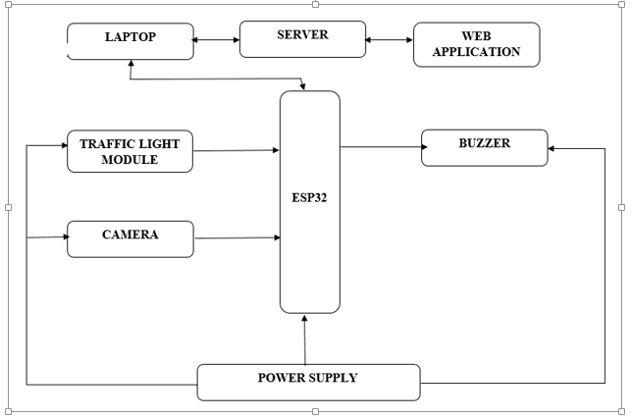
The system is composed of input devices, output devices and processors and a server that holds the data and also a database for storage of the data captured. The input devices which include the IP camera provide the input which is used in the decision making process by the processor and it also contains traffic light module which is an output device whose operation and timing are determined by the processor. The block diagram of the system consists of the main power supply, traffic light module, web camera, ESP32 microcontroller, and the computer for running then opencv software and the server hosting the database. The IP camera provides the feed that is capturing the images or video for use by the openCV software. The video captured is send to the server as frames that is as a series of pictures for improved throughput and easier processing and also avoid overwhelming the processor. The power supply provides the source of power for all the hardware to function properly.

System flowchart
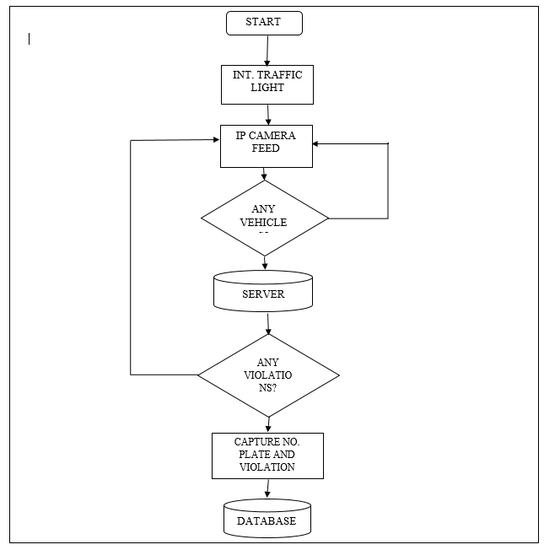

Requirements analysis
The researcher conducted a requirements analysis to identify the end-user requirements of the developed system. There should be communication between the developer and the system's end-users to determine user expectations. The activity's primary purpose is to understand what the users want clearly, as developers tend to go astray by following their developing instincts, thereby losing sight of the system requirements. Requirements analysis can be split into two that is functional and non-functional requirements.
Functional requirements
The description of the service that a system should offer comprise functional requirements, defining inputs, system processes, behavior, and expected outputs. They may include calculations, data manipulation, user interaction, or specific functionality. Functional requirements for the designed system include;
- Reading data from sensors for data acquisition
- Capture images or video of the road
- Extract the color of the road from captured images or videos
- Perform warping and thresholding
- Communication with raspberry pi computer
- Accessibility
Non-functional requirements
These specify the criteria that capture the quality attributes and system properties rather than specific functions and features. These include;
- Responsiveness of the system - there must not be a time lag between various components in the system.
- Error handling
- Reliability
- Maintainability
- security

Hardware implementation
Component selection

ESP32
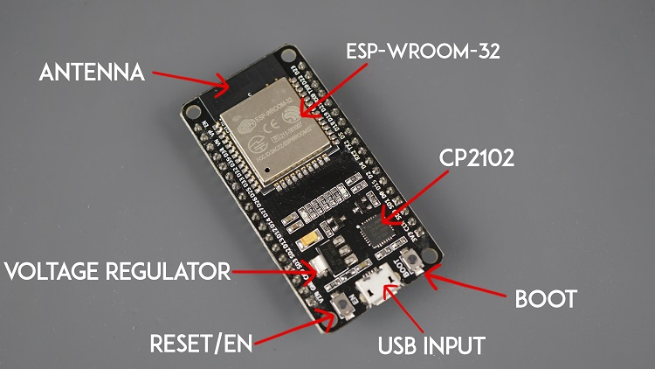
Fig 15: ESP32
The ESP32[30] is a powerful, low-cost Wi-Fi and Bluetooth-enabled microcontroller module. It is based on the ESP32 SoC (System on Chip) from Espressif Systems, which features two high-performance Tensilica LX6 CPU cores, along with a variety of peripherals such as SPI, I2C, UART, ADC, DAC, and PWM.
The ESP32 module supports a range of Wi-Fi and Bluetooth protocols, including Bluetooth Low Energy (BLE), Wi-Fi Direct, and Wi-Fi Protected Setup (WPS). It can be used for many applications, from simple IoT devices to complex automation systems.
One of the critical features of the ESP32 module is its low power consumption, which makes it ideal for battery-powered devices. It also has a large amount of built-in memory (up to 520KB), which allows for the development of more complex applications.
In addition to its hardware features, the ESP32 module is supported by a robust software ecosystem, including the Arduino IDE, MicroPython, and ESP-IDF (Espressif IoT Development Framework). This makes it easy for developers to get started with the ESP32 and to develop robust, custom applications.
The ESP32 module is a powerful, flexible microcontroller platform well-suited for many IoT and automation applications.

Raspberry Pi 4 Camera
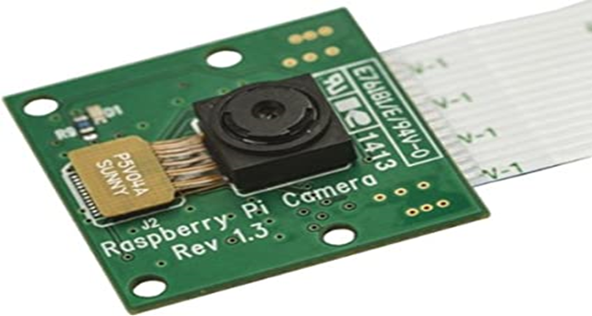
Fig 13: Raspberry Pi 4 Camera
The Raspberry Pi 4 Camera Module[28] is a small, lightweight camera designed for the Raspberry Pi 4 single-board computer. It can capture high-quality still images and videos, making it an excellent option for projects requiring visual data.
Here are some key features of the Raspberry Pi 4 Camera Module:
- Resolution: The camera module has a resolution of 8 megapixels, capable of capturing high-quality images and videos.
- Connectivity: The module connects to the Raspberry Pi 4 via a ribbon cable, making it easy to integrate into your projects.
- Size: The camera module is small and lightweight, making it easy to mount in tight spaces.
- Compatibility: The module is compatible with various software packages, including the official Raspberry Pi camera software and third-party options.
- Accessory options: There are a variety of accessories available for the Raspberry Pi 4 Camera Module, including mounting brackets, protective cases, and lens adapters.

Traffic light module
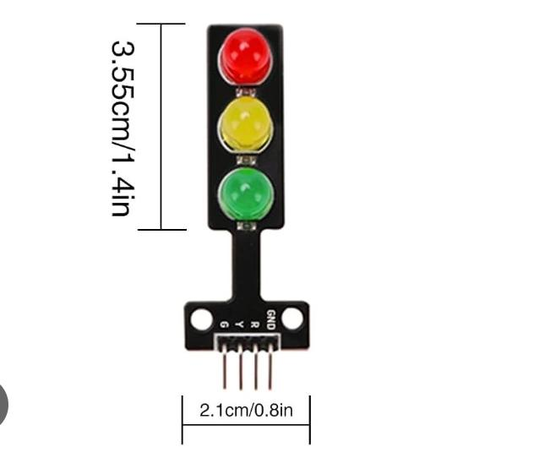
A traffic light module is a compact 5V LED board featuring red, yellow, and green lights designed for Arduino, Raspberry Pi, and DIY projects to simulate traffic signals. It typically uses a common cathode setup with 4-pin headers (R, Y, G, GND) and built-in resistors, making it easy to control brightness via PWM or direct digital high/low signals
Features and Specifications
- Operating Voltage: 3.3V - 5V DC.LED Size: Usually 5mm, sometimes 8mm diffused LEDs.
- Interface: 4-pin (Red, Yellow, Green, Ground).
- Control Method: Digital output (HIGH for ON, LOW for OFF) or PWM for brightness.Compatibility: Arduino, Raspberry Pi, ESP8266, ESP32.Structure: Common cathode (shared ground).
- Common Wiring with ArduinoModule R -> Arduino Pin 2 (or any PWM pin)Module Y -> Arduino Pin 3Module G -> Arduino Pin 4Module GND -> Arduino GND.

Power Supply
The block diagram of the power supply is used to illustrate the flow of power and signal through the power supply, as well as the functions of each component. The AC input is the connection point for the AC power source which is about 220V AC mains power. This power is typically stepped down to a lower voltage by the transformer. The rectifier converts the AC voltage to DC voltage. This is done using a full-wave rectifier. The filter smooth out the DC voltage by removing any ripple or noise that may be present. This is done using a capacitor. The regulator ensures the output voltage stays at a constant level, regardless of changes in the input voltage or load. This is achieved using a voltage regulator IC or a feedback loop. The output is the final stage of the power supply block diagram, where the regulated DC voltage (5V) is made available to the load.

Software implementation
The system database was designed using MySQL, a database with a different number of features that provides extra features like real-time database and cloudy based. A real-time database for the system was designed. The secret keys for the created database were copied and integrated with the developed Arduino code to enable the sensors to update the real-time environment on the database. The URL link copied in the system was used to link the database to the developed data dashboard, developed using C# code.
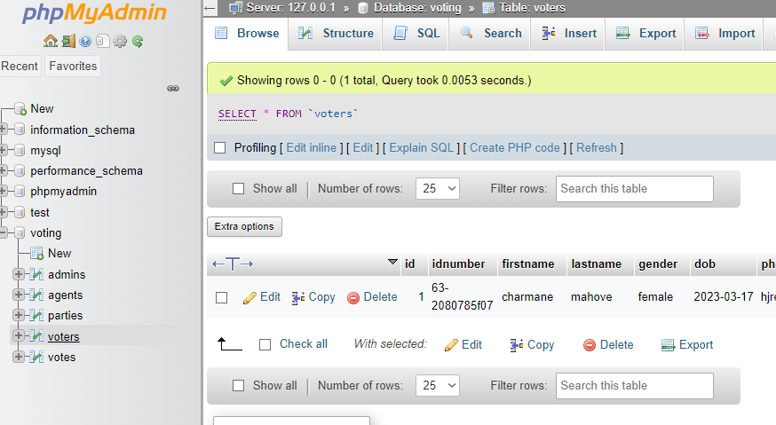

References
- Dube, C. (2024). Designing a Public Transport Service in the Zimbabwean Context. [Master's thesis, Masaryk University].
- Furusa, S. S., Mahlangu, G., Mugoniwa, B., Giyane, M., & Rebanowako, T. G. (2016). A conceptual Model for Highway Speed Monitoring and Enforcement in Zimbabwe. Journal of Systems Integration, 2016/4, 20.
- Mbara, T., Dumba, S., & Mukwashi, T. (2014). Multi-stakeholder dialogue on formal and informal forms of public transport in Harare, Zimbabwe: Convergence or divergence perspective. Journal of Transport and Supply Chain Management, 8(1). https://doi.org/10.4102/jtscm.v8i1.140
- Munuhwa, S., Chibaro, M., Mupfiga, C., & Farai, F. C. (2024). Human Factors and Road Traffic Safety: An Inquiry into the Causes of Road Traffic Accidents in Harare Metropolitan Province, Zimbabwe. Asian Journal of Management, Entrepreneurship, and Social Science.
- Mwale, M., Pisa, N., & Luke, R. (2024). Travel mode choices of residents in developing cities: A case study of Lusaka, Zambia. Journal of Transport and Supply Chain Management, 18. https://doi.org/10.4102/jtscm.v18i0.1005
- Ncube. (2025). Enhancing public-sector entrepreneurship: Evidence from Zimbabwean parastatals. Africa’s Public Service Delivery and Performance Review.
- Deshpande, S. V., Yede, T. S. and others (2026) 'Strategic traffic violation detection system', World Journal of Advanced Research and Reviews.
- Gambhire, G., Uplenchwar, R. and Patil, U. V. (2025) 'Automated traffic violation detection and E-challan system using YOLOv3 and IoT', Proceedings Article 10.1109/lotals67227.2025.11282128.
- Gehani, H., Rathod, S. and Purve, S. K. (2024) 'Traffic signal violation detection system using computer vision', Journal of Electrical Systems.
- Kaur, S., Muskan and Khera, P. (2025) 'Intelligent traffic violation detection and explanation system using computer vision and large language models', Journal Article 10.1109/icdiss68238.2025.11320729.
- Kusumaningtyas, E. M., Ahsan, A. and Ardystama, T. F. (2025) 'An automated traffic violation detection system based on YOLOv5', Proceedings Article 10.1109/ies67184.2025.11161248.
- Malik, A., Bisht, S. and Tripathi, Y. (2023) 'A framework for automatic detection of traffic violations', Proceedings Article 10.1109/incoft60753.2023.10425543.
- Rose, J. D., Aakash, S. and Aashish, V. (2025) 'Automated traffic violation detection and license plate detection for two wheelers with privacy preservation', Journal Article 10.1109/icces67310.2025.11336313.
- Singh, K. (2024) 'Automatic detection of traffic violations using YOLO model and challan generation', International Journal of Scientific Research and Engineering Trends.
- Tan, S. L. (2013) 'A method and system for automated monitoring of traffic', Patent.
- Thamilarasi, N., Shanmathi, B. and Kannagi, S. (2025) 'Development of an AI-based smart traffic guard system for real-time detection and automated penalty enforcement of traffic violations', Proceedings Article 10.1109/icirca65293.2025.11089648.
- Tulasidasu, B., Datta, P. S. and Naik, P. (2025) 'Two-wheeler traffic violations detection and automated penalty issuance system', International Research Journal on Advanced Science Hub.
- Uy, A. C., Quiros, A. R. F. and Bedruz, R. A. (2016) 'Automated traffic violation apprehension system using genetic algorithm and artificial neural network', Proceedings Article 10.1109/TENCON.2016.7848395.
- Weber-Pallez, C. (2021) 'Automated traffic rule violation detection with E-Challan generation for smart societies', Book Chapter 10.1007/978-981-19-1689-2_5.

